

Mohd. Razia Alangir Banu

MALLAVARPU BALA PRANITHA

2520030051
CSE
CO1 – Foundations & Sorting Algorithms

Case Study Topic: RetailMind – Smart Retail Inventory & Sales Analytics System (CO1 Focus: BST & AVL Trees)

Work Done Summary:
RetailMind is a smart retail inventory and sales analytics system that uses Binary Search Trees (BST) and AVL Trees to efficiently manage product data. BST is used for organizing and performing basic operations like insertion, deletion, and searching of product records, while AVL Tree is implemented to maintain balance in the dataset and prevent performance degradation. By applying rotation techniques such as LL, RR, LR, and RL, the system ensures that all operations run in O(log n) time. This improves the speed and efficiency of inventory management, stock updates, and product lookup in real-time retail environments.

Implementation Details:
- Product data such as Product ID, name, price, and stock is stored as nodes in a Binary Search Tree (BST).
- BST is used to perform basic operations like insertion, search, and deletion of product records.
- Data is organized in a hierarchical structure based on Product ID for easy retrieval and sorting.
- AVL Tree is implemented to overcome BST imbalance issues and maintain optimal tree height.
- After every insertion or deletion, balance factor is checked and rotations (LL, RR, LR, RL) are applied if required.
- The final structure ensures efficient operations with O(log n) time complexity for inventory management and product lookup.

Output:

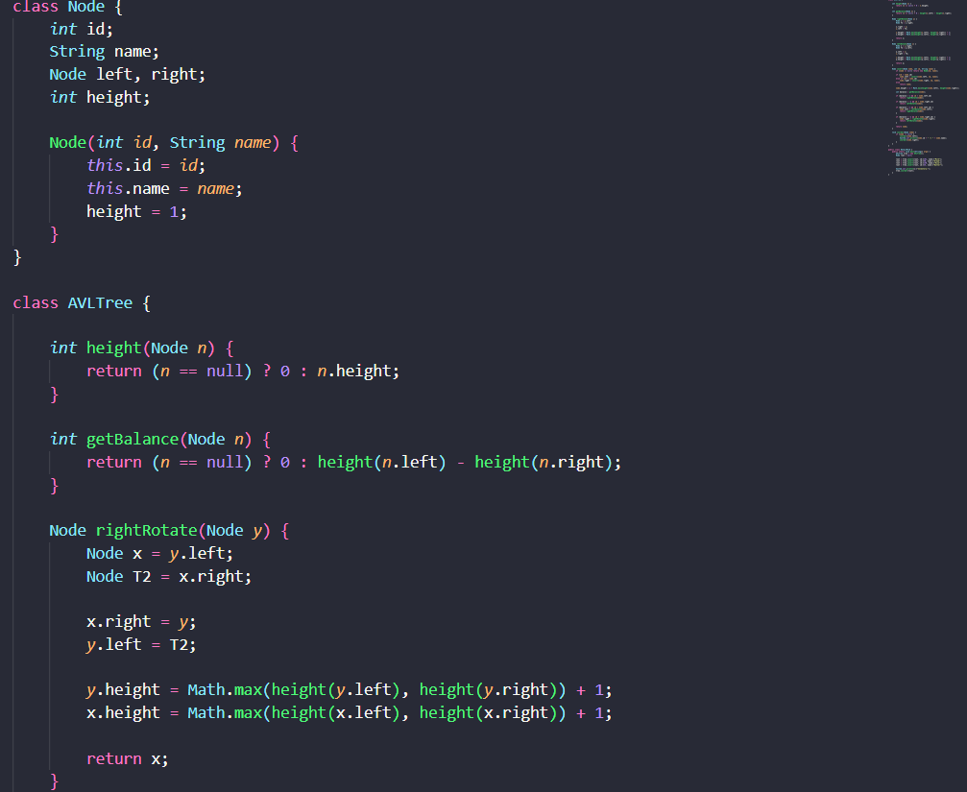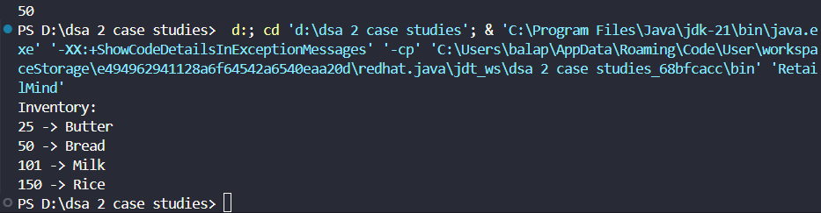

RetailMind efficiently manages inventory and sales data using BST and AVL Tree structures. BST helps in organizing product data for fast search, insertion, and deletion, while AVL Tree maintains balance using rotations to ensure consistent performance. This combination ensures all operations run in O(log n) time, improving speed, accuracy, and scalability in real-time retail inventory management systems.

Github link: https://github.com/balapranithamallavarapu-cmyk/DSA-II-Case-Studies

